Name : Ayush Anand
User id : 55952
Networks :
A computer network is a system that links numerous separate computers to exchange resources and information. Users can communicate more easily when computers and other devices are integrated. It is an assembly of two or more interconnected computer systems. Cable or wireless media can be used to establish a network connection. In any network, computers and tools are connected via hardware and software.
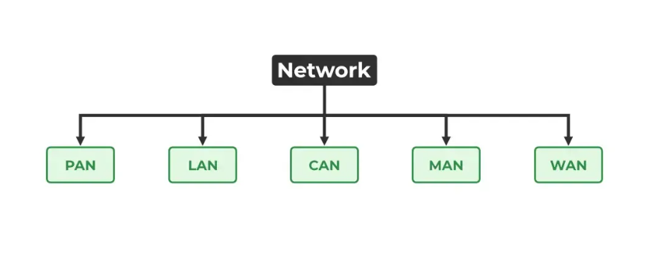
Types of networks are :
Networks can be classifies into various types depending upon the geographical area.
1.Personal Area Network(PAN)
It is a type of network designed to connect devices within a short range, typically around one person. It allows your personal devices, like smartphones, tablets, laptops, and wearables, to communicate and share data with each other. PAN offers a network range of 1 to 10 meters from person to device providing communication. Its transmission speed is very high with very easy maintenance and very low cost.
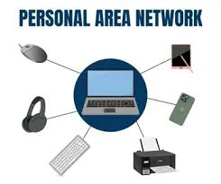
EG:- Wireless bluetooth connection between phone and wireless buds.
2.Local Area Network(LAN)
The most popular type of network is LAN. It is a computer network that links computers within a constrained space, or locally, via a shared communication channel. Two or more computers connected via a server are included in a local area network (LAN). Ethernet and Wi-Fi are the two key technologies used in this network. Its transmission speed is very high, its range is up to 2 km, and it is inexpensive and easy to maintain.
Eg:- WiFi in home or school.
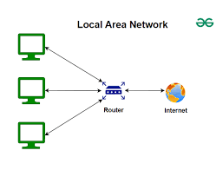
3.Campus Area Network(CAN)
This is a type of computer network that is usually used in places like a school or colleges. This network covers a limited geographical area that is, it spreads across several buildings within the campus. CAN mainly use Ethernet technology with a range of few kilometers. Its transmission speed is very high with a moderate maintenance cost and moderate cost.
Eg:-Network in a building or society.
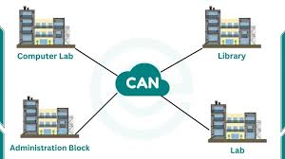
4.Metropolitian Area Network(MAN)
This kind of computer network uses a shared communication path across a city, town, or metropolitan area to link computers over a geographical distance. ATMs with a range of 5 to 50 kilometers are the primary technology used in this network. It has a mediocre transmission speed. It is expensive and challenging to maintain.
Eg:- Networking in towns, cities, a single large city.
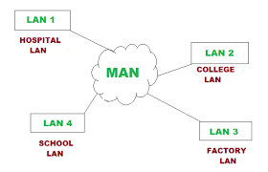
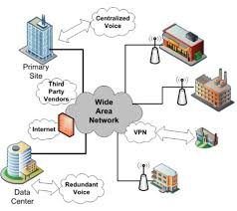
5. Wide Area Network(WAN)

WAN is a type of computer network that connects computers over a large geographical distance through a shared communication path. It is not restrained to a single location but extends over many locations. WAN can also be defined as a group of local area networks that communicate with each other with a range above 50km.
Eg:- Banking networks.

